**PURBANCHAL UNIVERSITY**



**DEPARTMENT OF COMPUTER ENGINEERING**

**KHWOPA ENGINEERING COLLEGE  
LIBALI-2, BHAKTAPUR**

**FINAL PROJECT REPORT**

**ON**

**CRICKET SCORESHEET**

**SUBMITTED BY**

Maulik Basnet (750316)

**SUBMITTED TO**

Milan Chikanbanjar

Date: 2077/12/16

**ACKNOWLEDGEMENT**

In performing this project, I had to take help and guideline of some respected persons, who deserve our greatest gratitude. I would like thank my teacher **Er. Milan Chikanbanjar** for his guidance and valuable support. I would also like to expand the deepest gratitude to all the faculty members of Computer Engineering Department of Khwopa Engineering College. We are also thankful to Purbanchal University who included the subject Free and Open Source Programming (FOSP) in the syllabus. I would like to thank my friends and seniors for their advice and guidance. I would also like to thank my family for the love and support they provided during completion of this project.

Maulik Basnet(750316)

**ABSTRACT**

Cricket is a very popular bat and bowl game. I follow this game very closely, and I love this game very much. Cricket is a game which consist many records and statistics. These are maintained as a record in many ways. For game, to see about the batsman, bowler, batting team, bowling team and overall game, scoreboard is used in ground. For future record it is maintained as a scoresheet. Nowadays scoresheet are maintained digitally. Along with scoresheet, live score update, cricketing news, different stats are maintained in applications and websites. My project cricket scoresheet is also website to maintain cricket scoresheet of limited over cricket. It keeps record of runs scored by batsmen and team, balls they faced, overs balled by bowlers and wickets taken by them.

**Table of Contents**

**INTRODUCTION** 1

1.1 Introduction 1

1.2 Motivation 1

1.3 Objective 1

1.4 Scope and Application 1

**METHODOLOGY** 2

ER Diagram: 2

Use Case Diagram 3

**RESULT AND DISCUSSION** 4

**CONCLUSION AND RECOMMENDATION** 8

4.1 Conclusion 8

4.2 Recommendation 8

**CHAPTER I**

# **INTRODUCTION**

## 1.1 Introduction

Cricket is a [bat-and-ball game](https://en.wikipedia.org/wiki/Bat-and-ball_games) played between two teams of eleven players on a [field](https://en.wikipedia.org/wiki/Cricket_field) at the center of which is a 22-yard (20-metre) [pitch](https://en.wikipedia.org/wiki/Cricket_pitch) with a [wicket](https://en.wikipedia.org/wiki/Wicket) at each end, each comprising two [bails](https://en.wikipedia.org/wiki/Bail_(cricket)) balanced on three [stumps](https://en.wikipedia.org/wiki/Stump_(cricket)). The [batting](https://en.wikipedia.org/wiki/Batting_(cricket)) side scores [runs](https://en.wikipedia.org/wiki/Run_(cricket)) by striking the [ball](https://en.wikipedia.org/wiki/Cricket_ball) bowled at the wicket with the bat (and running between the wickets), while the [bowling](https://en.wikipedia.org/wiki/Bowling_(cricket)) and [fielding](https://en.wikipedia.org/wiki/Fielding_(cricket)) side tries to prevent this (by preventing the ball from leaving the field, and getting the ball to either wicket) and [dismiss](https://en.wikipedia.org/wiki/Dismissal_(cricket)) each batter (so they are "out"). Means of dismissal include being [bowled](https://en.wikipedia.org/wiki/Bowled), when the ball hits the stumps and dislodges the bails, and by the fielding side either [catching](https://en.wikipedia.org/wiki/Caught) the ball after it is hit by the bat and before it hits the ground, or hitting a wicket with the ball before a batter can cross the [crease](https://en.wikipedia.org/wiki/Crease_(cricket)) in front of the wicket. When ten batters have been dismissed, the [innings](https://en.wikipedia.org/wiki/Innings) ends and the teams swap roles. The game is adjudicated by two [umpires](https://en.wikipedia.org/wiki/Umpire_(cricket)), aided by a [third umpire](https://en.wikipedia.org/wiki/Third_umpire) and [match referee](https://en.wikipedia.org/wiki/Match_referee) in international matches. They communicate with two off-field [scorers](https://en.wikipedia.org/wiki/Scoring_(cricket)) who record the match's [statistical information](https://en.wikipedia.org/wiki/Cricket_statistics).

Cricket scoresheet is statistical paper in which in game information and data are stored. They are displayed in score board in ground. Nowadays they are maintained digitally, using different application and websites. Plenty of previous records can also be stored in the database. To make application more attractive and multipurpose, websites and application also keep additional records, latest news, and upcoming fixtures.

## 1.2 Motivation

Cricket scoresheet are used to keep records of the cricket game. It helps to give information of the game to general people. Nowadays in the age of digital technology, digitally cricket scoresheet is preferred and there are several of these type of digital application and programs, but generally they don’t work for domestic tournaments of our country. Being a cricket lover, I myself like to be in touch with the game. So I decided to develop this scoresheet as my project so that it will be useful to keep records of our domestic games in future.

## 1.3 Objective

* To create a website to maintain scores of different national and international Cricket games.

## 1.4 Scope and Application

This application is useful for cricketing area and is for cricket lovers who want to follow scores of national and international games regularly.

**CHAPTER II**

# **METHODOLOGY**

## ER Diagram:

User

Admin

Views

Creates

Matches

Has

Has

Has

First Innings Batting Score

Second Innings Batting Score

Second Innings Bowling Score

Has

First Innings Bowling Score

## Use Case Diagram

Admin Matches User

**CHAPTER III**

# **RESULT AND DISCUSSION**

Following are screenshot of my project:

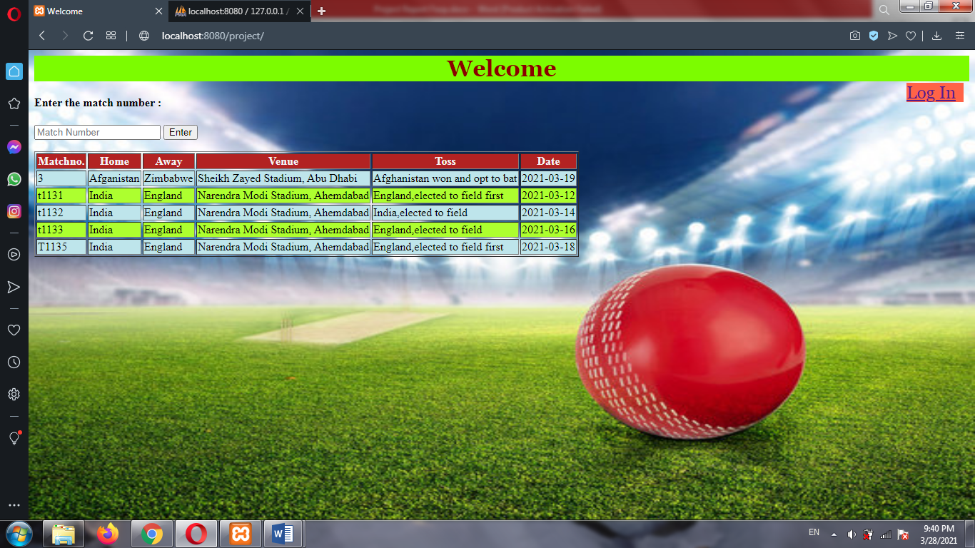

Picture 1: Index Page

My Project starts with an index page. Log in Option is available for admin. User can select desired match from given list.

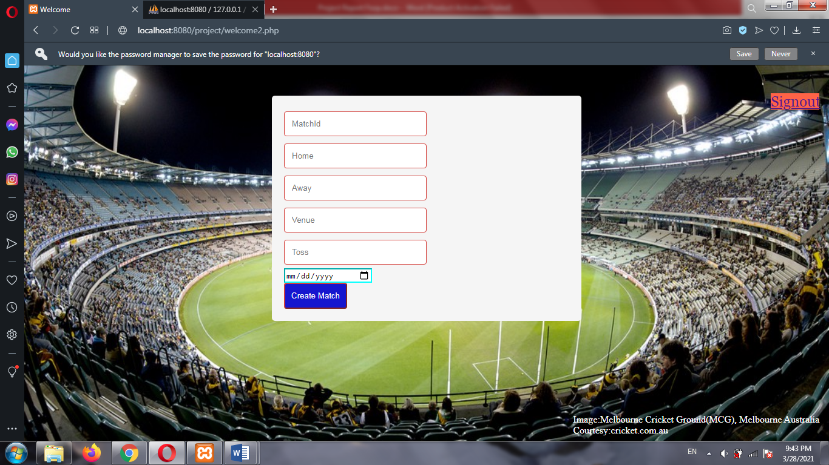

Picture 2: Create Match

When admin logs in, then page shown in picture above appears. When match is created, First innings batting detail followed by first innings bowling details, Second Innings Batting and Second Innings Bowling details are asked.

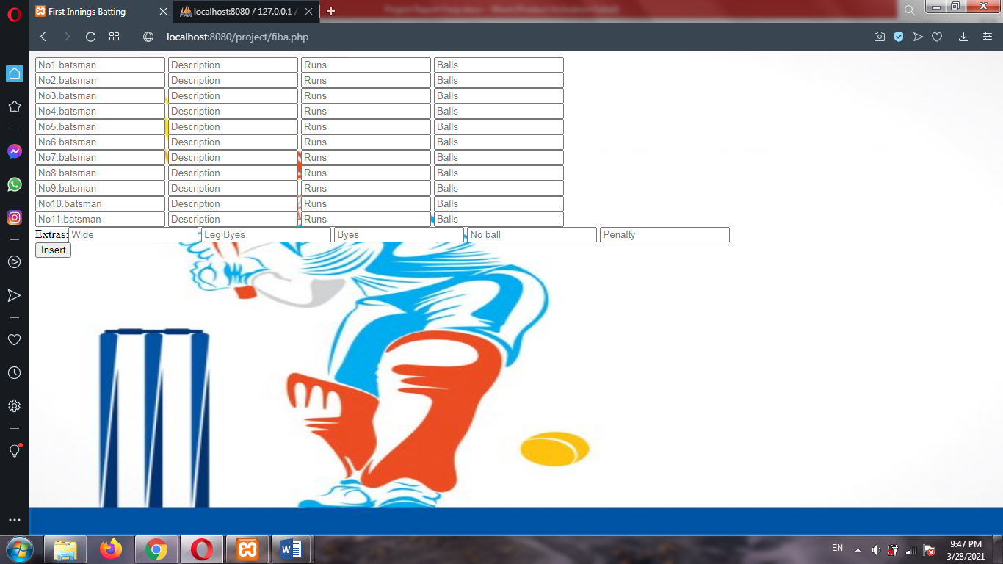  
Picture 3: First Innings Batting form

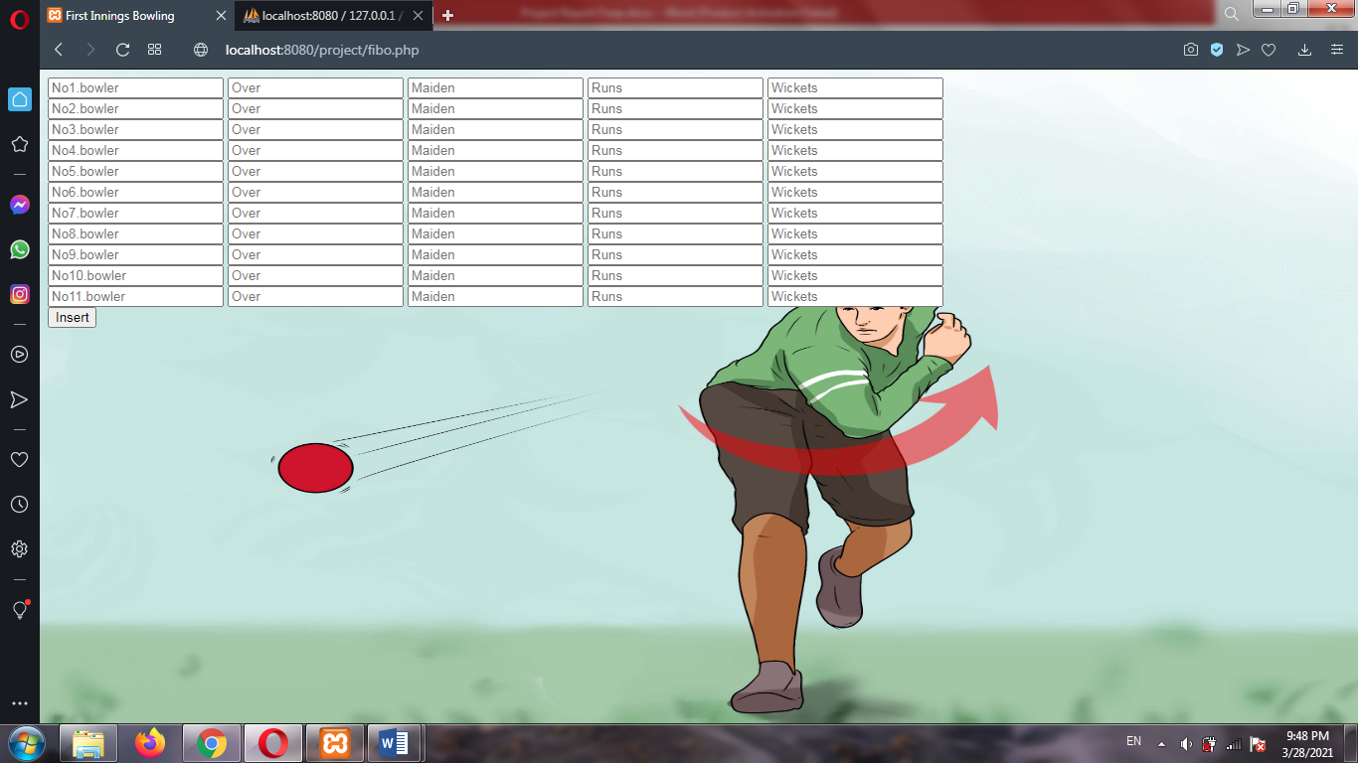

Picture 4: First Innings Bowling form

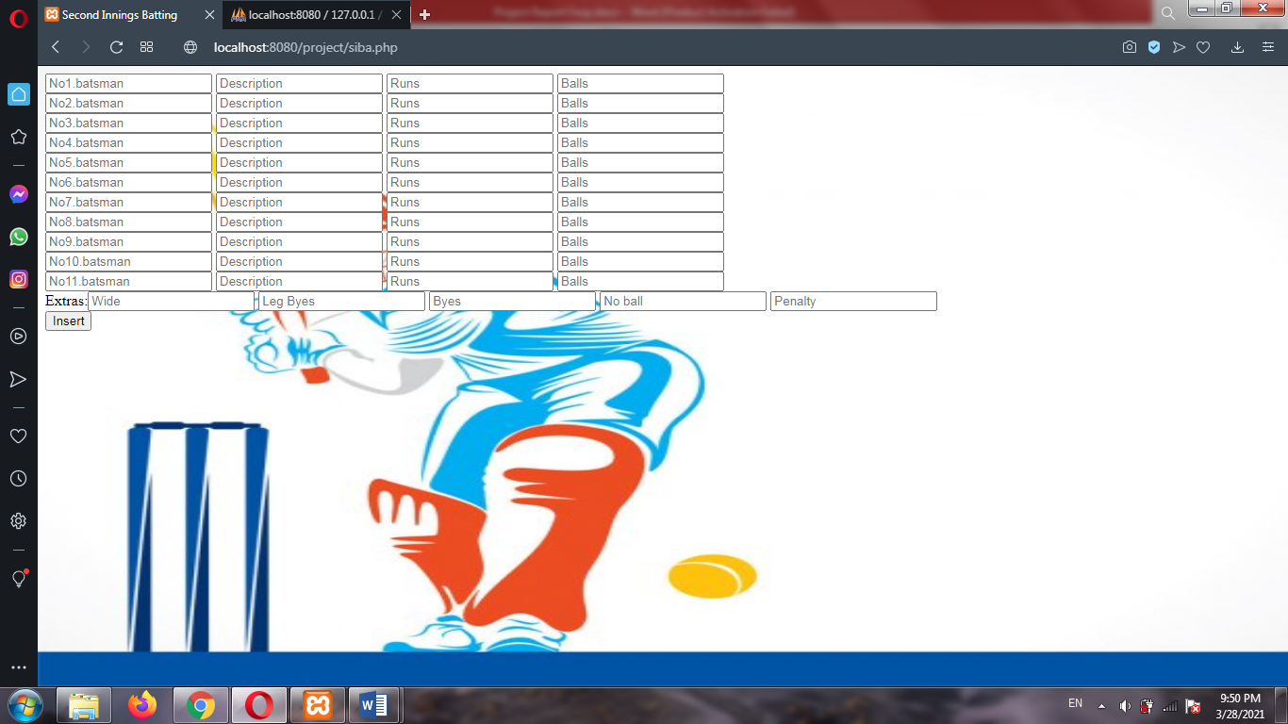

Picture 5: Second Innings Batting form

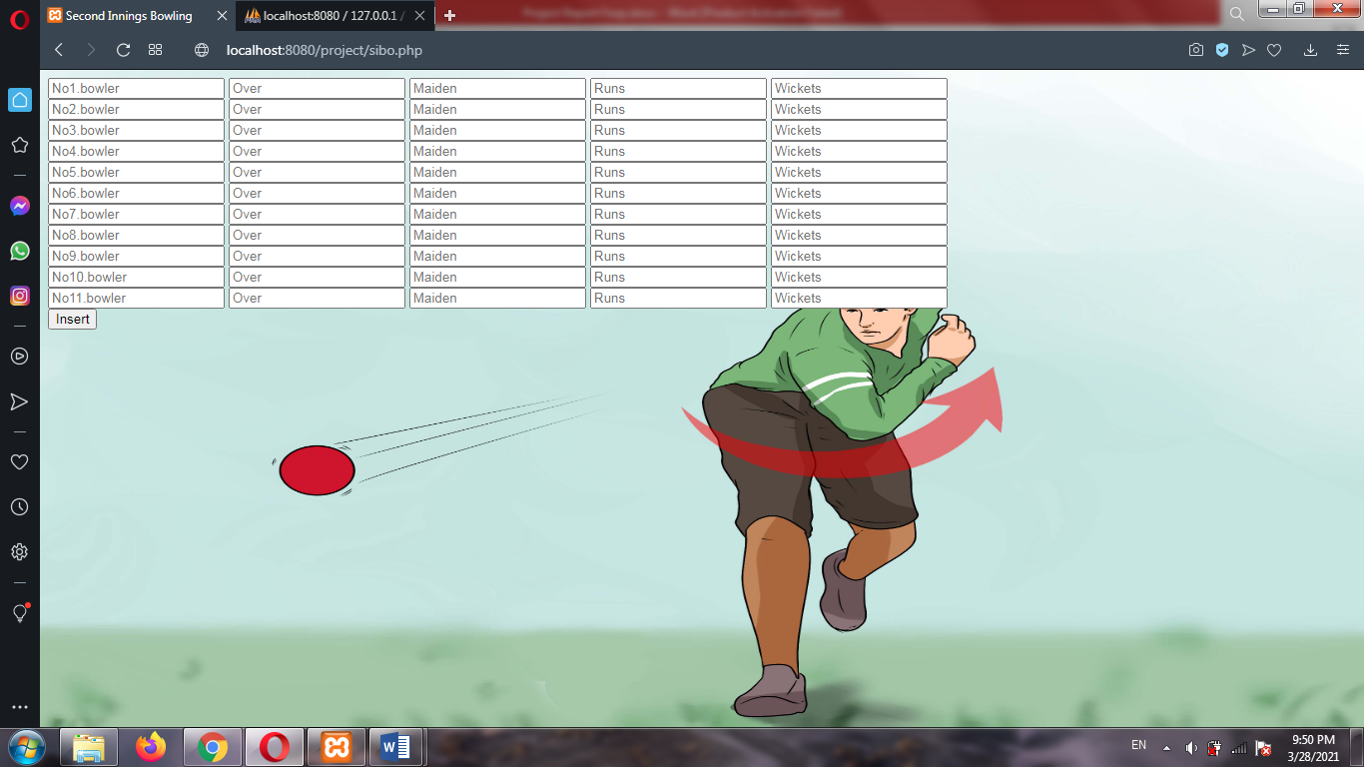

Picture 6: Second Innings Bowling form

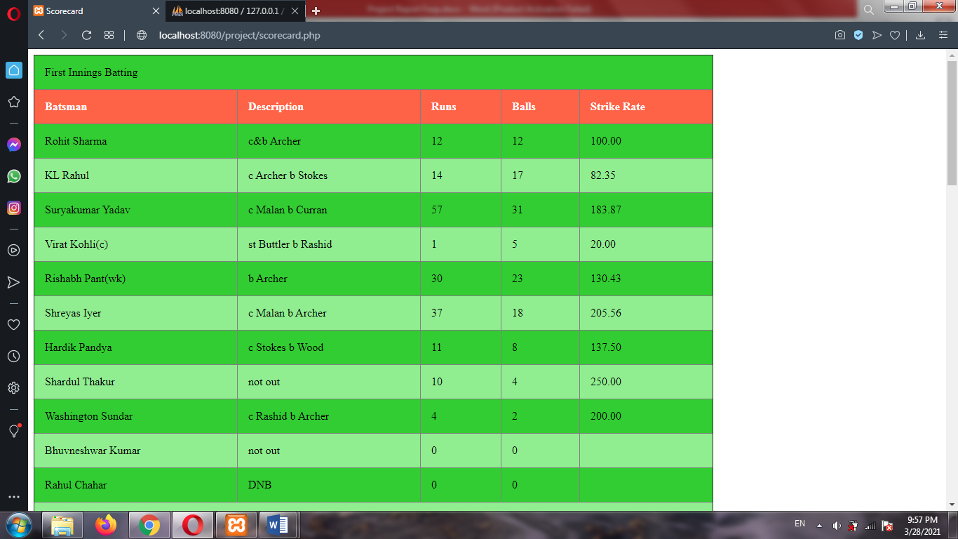

Picture 7: Scorecard

**CHAPTER IV**

# **CONCLUSION AND RECOMMENDATION**

## 4.1 Conclusion

This was a small effort to make Cricket Scoresheet. Although I tried my best to make the project good and efficient there are still some limitation. Some limitation are:

* This is scoresheet for finished game only. Live updates cannot be performed.
* Ball by Ball update cannot be performed.
* Some data have to be typed manually.

## 4.2 Recommendation

For future I recommend following:

* Ball by Ball updates.
* Give select option for things that have to be typed manually.
* News, upcoming fixtures could also be added.